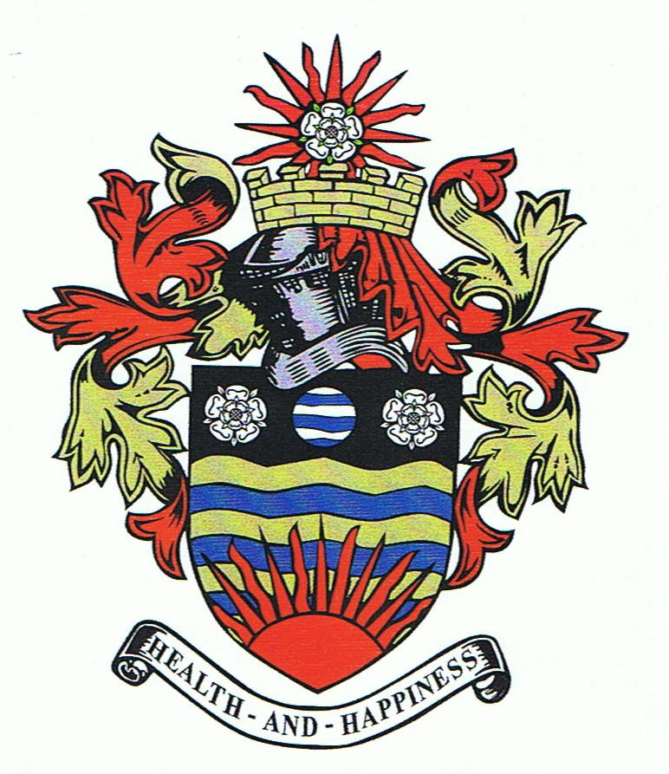

HORNSEA TOWN COUNCIL
Policy for S137 Grant Fund

The council awards grants to voluntary organisations and community groups, which in the opinion of the Council are in the interests of the parish and will benefit them in a manner commensurate with the expenditure and where financial need is demonstrated.

All applications will be considered on their individual merits. The final decision on assessment of applications and the level of any award offered lies with the Council.

You can apply if you fit the following criteria?

- You are a not for profit group operating for the benefit of the community in the Town of Hornsea
- You have a constitution or set of rules
- You have a Bank / Building Society Account with at least two signatories

What the Council will not fund?

- Loan repayments
- Retrospective applications where the activity or project has already been carried out
- Religious or political activities unless unrestricted community benefit can be demonstrated
- Applications for the benefit of an individual
- Any group that has received a grant from the Council within the current financial year
- Any group whose aims the Council considers to be working within a business or profit making remit.

Amount of Grant?

- Applications for up to £100.00 will be considered, however the average allocation is between £50.00 and £100.00.

Conditions

- If the grant is put to purposes other than those for which it was awarded without the prior approval of the Council, the recipient organisation shall be required to repay the grant
- The organisation shall supply copies of any financial information the council may need
- The organisation should supply such information as the Council may request regarding the impact of the project on the town of Hornsea or its inhabitants.
- Recognition of the grant from the Council must be made in any publicity

When to apply?

- Grants are considered on a rolling program, there are no time restrictions for applications
- A written application should be forwarded to the Town Clerk
- You may be asked to attend the meeting to provide any additional supporting information and answer any questions the Council might have
- Applicants will be notified within a month of the meeting of the Council

How is an application considered?

The Council will consider applications on the following basis:

- How well the grant will meet the needs of the community
- How effectively your group will use the grant
- Whether the costs are appropriate and realistic
- Level of any contributions raised locally
- Whether the applicant could reasonably have been expected to obtain sufficient funding from a more appropriate source
- How the group is managed
- How the grant positively benefits residents residing within this parish.

If you wish to apply for a grant please write with details to:-

The Town Clerk
Hornsea Town Council
Town Hall
75A Newbegin
HORNSEA
HU18 1PA

Email: clerk@hornsea.gov.uk

TOWN CLERK
March 2021

Reviewed: Town Council meeting – Monday 22nd August 2022
Minute ref: 14) c)

