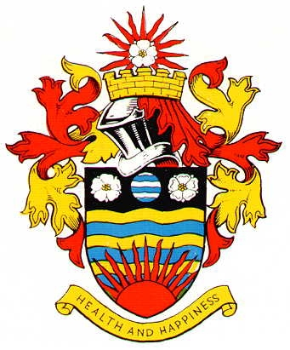
Hornsea Town Council Equality, Diversity and Inclusion Policy

Hornsea Town Council is compliant with all Equality legislation in line with the 9 protected characteristics and ensures that these are consistently applied in all areas of our operation.
We are mindful that treating everyone in the same way can disadvantage some people/staff/residents, therefore we are mindful of the need to make adjustments and accommodate needs to ensure a level playing field.
This policy is applicable to all staff, council members and anyone carrying outwork for and on behalf of Hornsea Town Council.
Hornsea Town Council:
• recognises that everyone has a contribution to make to our society and a right to equal opportunity;
• values people from all backgrounds and believes they have a right to be free from prejudice and discrimination;
• recognises that discrimination can be overt or covert – open or hidden
No job applicant or employee, member, volunteer or organisation/individual to whom we provide services will be discriminated against by us on the grounds of:
• age;
• gender (including sex, marital status and gender re- assignment);
• race (including ethnic or national origin, skin colour and nationality);
• disability;
• sexual orientation;
• religion or belief;
• social or economic status;
• pregnancy or maternity
(This is not an exhaustive list)
We aim to promote equal opportunities, eliminate discrimination and eliminate harassment through the following:
• opposing all forms of unlawful and unfair discrimination;
• treating fairly and with respect all employees (whether part-time, full time or temporary), volunteers, councillors and beneficiaries;
• advertising vacancies as widely as possible, in accordance with needs and resources; • selecting for employment /volunteering, promotion, training or any other benefit on the basis of aptitude and ability with all selection/rejection decisions being recorded;
• helping and encouraging all employees/volunteers/members to develop their full potential and using the talents and resources of individuals to maximise the efficiency of the council;
• focusing on ability not disability. The council is committed to:
• creating an environment in which individual differences and the contribution of staff, members, volunteers and beneficiaries are recognised and valued
• creating an environment that promotes dignity and respect to all and that does not tolerate intimidation, bullying or harassment
• making training opportunities available to all
• encouraging staff and volunteers to look at their personal/career development

Adopted: Town Council meeting – 28th April 2025 – Minute ref: 11

