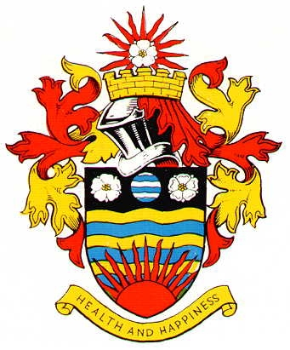
HORNSEA TOWN COUNCIL
MINUTES OF THE PROCEEDINGS OF A MEETING OF THE HORNSEA TOWN COUNCIL PERSONNEL COMMITTEE

HELD ON MONDAY 14TH NOVEMBER 2022

Present: Councillors: L Embleton, C Morgan-Muir, A Robinson, J Greensmith and T Bunch

In attendance J Richardson – Town Clerk

- Apologies for absence
There were no apologies

Due to the following items involving discussions directly related to individual staff members and others it was RESOLVED that they be taken IN CAMERA

- Approval of the Minutes of a meeting held on 24th October 2022
The Minutes of a meeting held on 24th October were approved as a correct record of proceedings thereat

- Weekend Working /litter bins a) Bins – skate park – Cllr J Greensmith gave a report on litter bins and confirmed that no additional bins are required at the skate park/play area – RESOLVED noted
b) Bin – Cinema Street Car park – it was RESOLVED that a larger litter bin be installed at the Cinema Street Car Park
c) Bins/litter – problem areas – it was reported that there are no real problem areas at this time – RESOLVED noted

- Appraisals 2022 a) Staff salaries – Following discussion it was RESOLVED that salary scale points for GO and MP be amended as discussed and the situation be reviewed again in 6 months time
b) Appraisal forms – the Town Clerk gave details of appraisals carried out with DS and MO. It was RESOLVED that DS job role be reviewed again in 6 moths time, a quotation to purchase a hand held vacuum be sought, “recycling – room bookings” be deferred to the Climate Change working group for further discussion and “cleaning of the town council depot” be referred to the Town Council for further discussion

- Detached Youth Workers – update
The Town Clerk confirmed that the new detached youth work team is now in place and contact has been established with the Police and various other agencies, detached youth work will begin in Hornsea as of 21st November – RESOLVED noted

- Apprentice/staffing needs
The Town Clerk gave details of comments made by GO. It was RESOLVED that appraisals be carried out with JR and GO on Monday 28th November at 1.00pm and 2.00pm respectively

- Christmas closing
It was RESOLVED that the town hall close for Christmas holidays as of 4.00pm on Wednesday 21st December

