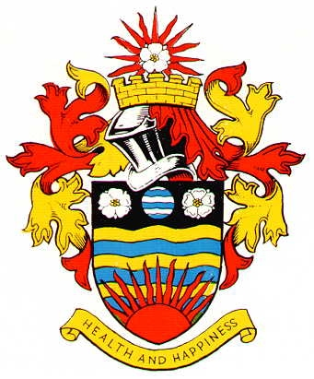
Hornsea Town Council - Working Groups
Terms of Reference
Full Council and/or the Parks and Cemeteries Committee may form or disband a Working Group at any time. The Working Group will carry out tasks as defined by Full Council and/or the parks and Cemeteries Committee.
Any necessary specific terms of reference, including, if required, delegated powers, will be prepared by the Town Clerk.
The Role of Working Groups to Hornsea Town Council will be:-
• To tackle issues as directed by the Council
• To be task specific
• To examine an issue in detail, read reports and related materials, examine options, obtain advice on behalf of the Council if necessary
• To liaise with experts if/when necessary
• To make recommendations to Council
• To explain the recommendations, reasons, options to Full Council and/or Parks and Cemeteries Committee by way of a written report
• To answer questions from the Council
• No funding or monies to be spent or committed without delegated authority or prior Full Council and/or Parks and Cemeteries Committee endorsement
Working Groups relationship
• Full Council and/or the Parks and Cemeteries Committee must direct the Working Group and set clear terms of reference for them regarding objectives, scope and outcome
• The role of Full Council and or Parks and Cemeteries Committee is to question and challenge the recommendations in order to be satisfied of the correct decision
• The Working Group must facilitate the Full Council and/or Parks and Cemeteries Committee with as much information as it requires to ensure it can make a properly informed decision on its recommendation
Operations of the Working Group
• A Working Group will have not have a budget
• The number of Councillors on a Working Group to be decided on at time of the Working Group appointment
• The leader of the Working Group to be appointed by the Full Council and/or Parks and Cemeteries Committee at the time of the Working Group appointment
• A Working Group must consist of at least 3 Councillors
• Quorum: Minimum of 2 Councillors at each meeting
• Co-option of named experts/non councillors to be approved by Full Council and/or Parks and Cemeteries Committee
• Written and/or verbal reports of Working Group meetings to be prepared to Full Council and/or Parks and Cemeteries Committee to report on any activity and progress
• Working Groups do not meet in public therefore Standing Orders are not applicable, the Code of Conduct still applies

To be reviewed annually

